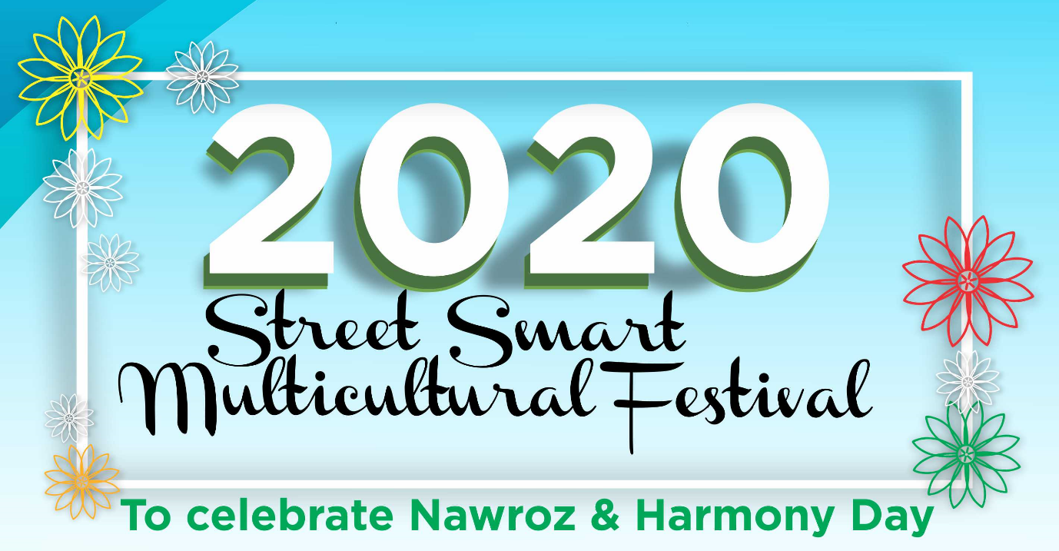

Street Smart Multicultural Festival 2020 – Stall Holder Category Expression of Interest (EOI) Form
Organisation Details
*Organisation Name
*Name of organisation/group that you want printed in the event program
*Ethnicity
*Country of origin
*Organisation’s Postal address
Street:
Suburb: |  |  | State: |  |  |  | Post Code:
Phone: |  |  |  | Email:
Contact Details – Main contact person for the festival
*Title
Mr | Mrs | Ms |  |  |  | Miss |  | Other
*First name
*Last name
*Position title
*Phone
*Mobile
*Email address
Alternative contact person
*Title
Mr | Mrs | Ms |  |  |  | Miss |  | Other
*First name
*Last name
*Position title
*Phone
*Mobile
*Email address
Performance opportunity
*Please select the option that best describes your stall (you can choose more than one option)
Food and/or business stall
Cultural display stall
Educational and informational stall
For groups and organisations that are expressing their interests to have a food stall, please complete the additional details.

*What type of food will you provide? Please provide as much details as possible. (for example, will your food be sweet or savoury, the name of food (if known to ensure we will have a variety of food at this festival
*Do you need to cook or prepare your food on site at this festival?
Yes |  |  |  |  | No
*Will you bring food already prepared?
Yes |  |  |  |  | No
*Will you require power?
Yes |  |  |  |  | No
For groups and organisations that are expressing their interests to have a cultural or educational and informational stall, please complete the additional details.

*Please describe what will you provide in your stall?
*We will provide a trestle table and 2 chairs for each stall. Do you need to bring any additional furniture/equipment? If so, please provide more information about this extra stuff.
Note: you have to negotiate with the event coordinator if you need to bring additional stuff. All WHS requirement must be met.
Declaration
I have read and agreed to the terms and conditions outlined in the 2020 Street Smart Multicultural Festival guideline/factsheet
By submitting this expression of interest (EIO) I declare that:
*The information provided in this form is correct and accurate to the best of my knowledge
*I am the authorised person from abovementioned organisation/group to submit the EIO
*I understand that submitting the EIO does not guarantee our participation.
*Full Name:
*Position title:
*Signature:
*Date:

If you have any question about this Expression of Interest form or about the festival, please contact the event coordinator Sahar Khajani on 0477921830 / sahar@bmfoundation.com.au

